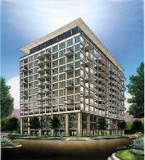
125 East 13th Street,
Chicago, IL 60605
(312) 235-0486
www.125east.com

MUSEUM PARK LOFTS CONDOMINIUM ASSOCIATION
ENTRY AUTHORIZATION

Date: _________________Unit Number: _________Phone Number: _________________

This will serve as Authorization to a Museum Park Lofts staff member to release keys for the above unit, to the person(s) specified:

Name(s): _____________________________________________________

Company: _____________________________________________________

Purpose: ______________________________________________________

Effective from: ________________To: _________________

Comments: _______________________________________________________

The undersigned agrees to hold harmless the Museum Park Lofts Condominium Association, its Officers and Directors, Employees and its Management for any claim for loss, damages and/or injury connected in any way with the release of the aforesaid unit keys and entry of the aforesaid person for any act or service to the unit specified above.

Signed: ___________________________________________Date: ______________________

